**INDOOR AIR QUALITY MONITORING PHASE 3:DEVELOPMENT PART 1**

**Hardware Design:**

Hardware equipment that we need in order to built the project are given below:

1.Microcontroller(raspberry Pi or Arduino with a Wi-Fi)

2.Temperature and Humidity Sensor:DHT22/DHT11

3.Carbon Dioxide(CO2)Sensor:Non-Dispersive Infrared (NDIR)Sensors

4.Volatile Organic Compounds(VOC) Sensors:SGP30

5.Air Quality Sensors:MQ Series Sensors,Bosch BME680

6.Carbon Monoxide(CO) Sensors:NDIR CO Sensor

**Block diagram:**

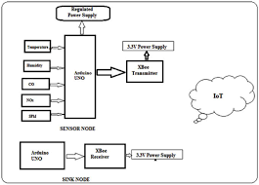

**Flow Chart:**

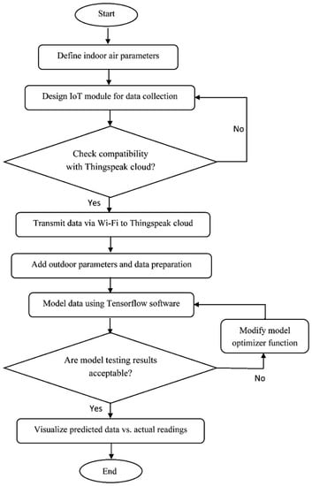

**CODE:**

**# Import necessary libraries**

**import time**

**import board**

**import busio**

**import adafruit_ccs811 # For the CCS811 CO2 sensor**

**import requests**

**# Set up the CCS811 sensor**

**i2c = busio.I2C(board.SCL, board.SDA)**

**ccs = adafruit_ccs811.CCS811(i2c)**

**# ThingSpeak API key and endpoint**

**THINGSPEAK_API_KEY = "YOUR_THINGSPEAK_API_KEY"**

**THINGSPEAK_ENDPOINT = f"https://api.thingspeak.com/update?api_key={THINGSPEAK_API_KEY}"**

**# Function to read sensor data and send it to ThingSpeak**

**def send_to_thingspeak():**

**try:**

**# Read sensor data**

**temperature = ccs.temperature**

**humidity = ccs.humidity**

**co2 = ccs.eco2**

**# Display data locally**

**print(f"Temperature: {temperature} C, Humidity: {humidity}%, eCO2: {co2} ppm")**

**# Send data to ThingSpeak**

**payload = {"field1": temperature, "field2": humidity, "field3": co2}**

**response = requests.post(THINGSPEAK_ENDPOINT, params=payload)**

**# Print the response from ThingSpeak**

**print(f"ThingSpeak Response: {response.text}")**

**except Exception as e:**

**print(f"Error: {e}")**

**# Main loop**

**while True:**

**# Wait for the sensor to be ready**

**while not ccs.data_ready:**

**pass**

**# Call the function to read sensor data and send to ThingSpeak**

**send_to_thingspeak()**

**# Wait for some time before the next reading**

**time.sleep(60) # Adjust the sleep duration based on your requirements**